RECOMMENDATION FOR MENTORS/CO-MENTORS

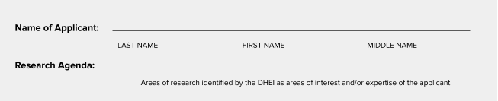

The GEMS Program Implementing Unit greatly appreciates your cooperation in assessing the Applicant as possible Mentor / Co-Mentor for the Graduate Education Mentoring for Scholars (GEMS). To assist in the selection process, we would like to receive your views on the applicant’s suitability as possible mentor to lead the GEMS scholars in the pursuit of scholarly work.

- How long you have known the applicant and in what capacity?

✔ | Connection | Number of Months / Years
 | As his supervisor
Others (please specify)

____________________

- Rate the applicant against the following criteria. Please check (✔) the appropriate answer.

Characteristics | Outstanding | Satisfactory | Unsatisfactory | Poor
Ability to share skills, knowledge, and expertise
Commitment to helping his/her mentees find success
Ability to encourage ongoing learning and growth in the field
Ability to guide and provide constructive feedback
Values the opinions and initiatives of others
Compassionate
Integrity
Initiative
Resourcefulness
Responsibility
Carefulness in work
Compliance with policies and procedures
Ability to work with others
Written communication skills
Verbal communication skills

- Which overall recommendation would you give? Check one option only.

✔ | Recommendation
 | I highly recommend the applicant as mentor / co-mentor
 | I recommend the applicant as mentor / co-mentor
 | I recommend with the following reservation
 | I do not recommend the applicant

If there are any important comments you would like to give which are not sufficiently covered by the above questions, we would greatly appreciate it if you provide them below:

___________________________________________________________________________

___________________________________________________________________________

___________________________________________________________________________

Referee’s Details
Name:
Position:
Institutional Affiliation and Address:
Tel No.:
Email Address:
Date/Signature:

