ANNEX:
How to include the credit load incentive for course pack preparation in the faculty service record

NOTE: This guide is only for faculty who opted to claim the credit load incentive to fulfill the teaching load requirement INSTEAD of the honorarium for course pack preparation this 1st semester AY 2020-2021.

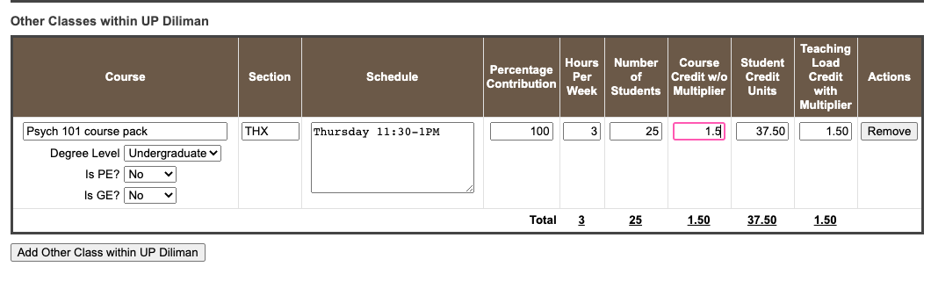
General instruction: The credit load incentive needs to be manually indicated in the faculty service record in the fields under the category “Other Classes within UP Diliman.
This is your credit load incentive.
6
5
4
3
2
1

- Click “Add Other Class within UP Diliman.”
- Under “Course,” input [course] course pack (e.g., Psych 101 course pack).
- Fill-in the other details such as “Section,” “Schedule,” “Hours Per Week,” and “Number of Students.”
- Input the “Percentage Contribution” pro-rated among faculty involved in the course pack preparation (e.g., 100 if 1 faculty worked on the course pack, 50 if 2 faculty worked on the course pack, 33.33 if 3 faculty worked on the course pack, and so on).
- Under “Course Credit w/o Multiplier,” input the corresponding credit load incentive based on the number of units of the course:

Number of Units of the Course | Credit Load Incentive
1 unit | .5
2 units | 1
3 units | 1.5
4 units | 2
5 units | 2.5

- DO NOT CHANGE the settings for “Degree Level,” “Is PE,” and “Is GE” fields as seen in the screen capture above. This is to ensure that the basis of the computation of the “Teaching Load Credit with Multiplier” will only be the Percentage Contribution and Course Credit w/o Multiplier.

The credit load incentive should now be reflected in the “Teaching Load Credit with Multiplier.” It should also be reflected in the “Total Teaching Load” and “Total Faculty Load in Credit Units” in your FSR.

For questions and/or assistance, please email OAT (ovcaa.oatdiliman@up.edu.ph) and OVCAA (ovcaa.upd@up.edu.ph). Thank you.

